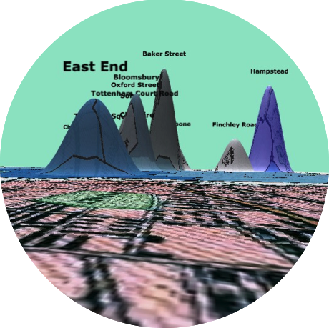

Lesson Plan | Mapping Interfaces

This exercise asks us to think about the theories and values that figure into the design of a mapping interface. To so do, we will map the same short story in two different mapping environments—Google Earth and the Z-axis Tool. Each mapping exercise is paired with a theoretical text that discusses the theories and values of spatial and cartographic representation. Reading across both environments, as we consider the affordances and constraints of each platform, we will build platform literacy as we learn to read and critique online mapping environments. This literacy will be expressed through a multimodal essay that identifies and evaluates the assumptions of flat and warped mapping platforms, concluding with recommendations for improving each.

As a capstone to this lesson plan, a hybrid essay that blends writing with multimodal evidence of work done in each mapping environment may be assigned.

Texts
Please choose one of the following:
Virginia Woolf, “Steet Haunting: A London Adventure”

H.G. Wells, The War of the Worlds
Recommended Chapters: II.14 (In London), II.15 (What Happened in Surrey), II.16 (The Exodus from London), III.8 (Dead London)

Sir Arthur Conan Doyle, The Sherlock Holmes stories
(choose one or several)

Instructions
Map the novel in Google Maps
https://www.google.com/maps
I. Reading
Peter Turchi, “Metaphor: Or, the Map”

II. Mapping
In order to learn how to create your own map using Google Maps, follow the instructions at https://support.google.com/mymaps/answer/3024396?hl=en.
This process requires manually adding locations. Add what you consider to be the top ten most important locations in the text to your map, along with a short annotation explaining the importance of that location (even a short quotation will do).

Map the novel using the z-axis tool
http://zaxis.uvic.ca/
I. Reading
Guy Debord, “Introduction to a Critique of Urban Geography”

II. Mapping
In order to learn how to create your own map using the Z-axis Tool, follow the instructions at http://zaxis.uvic.ca/#section-two.
This process automatically identifies locations. Be sure to remove “London” from the list of automatically identified place-names, as well as any anomalous entries.

Discussion
Consider the following questions:
- Describe your experience using both tools. How did your experience using the interface frame or shape the way you thought about the story you mapped? What changes would you propose to each interface based on this experience?
- What are the theoretical and practical differences between base maps and warped maps?
- What assumptions about space does each platform express?
- How might we “read” an online map in the same way we read a story?
- Does one map appear more “true” or “accurate” than the other? Why or why not? (This is a trick question.)
- Where would you draw the line between reality and art? Is one map more “real” than the other? Again, why or why not. (This is also a trick question.)

Further Reading
Bethany Nowviskie, “Neatline and visualization as interpretation”
JB Harley, “Deconstructing the Map”
Denis Wood, “A Map in an Image Proclaiming its Objective Neutrality”

